Anti-Bullying Awareness and Peer on Peer Abuse Guide

Created by the Children of Hollymount School

**Frequently Asked Questions**

**Who can you go to if you are being bullied?**

There are many different people that you can go to if you are being bullied.  These include:

Teachers

Friends

Family (siblings, parents, grandparents)

Lunchtime supervisors

Guardians

A trusted adult

Social workers

Childline 0800 1111

**How can your friends help if you’re being bullied?**

If you are being bullied, your friends are there to cheer you up, play with you and help you feel better.  They can help you tell the teacher or a trusted adult so that it can be investigated properly.  If you are being bullied online or over the phone, your friends can help you to log off or show you how to block people.  If they feel brave enough, they could speak to the bullies to find out why they are doing it and see if they can find a way for them to stop.

**What will your teacher do if you are being bullied?**

The teacher will investigate first and then give appropriate consequences.  They will inform the parents of the victim and the bully and will report it to the Head of school and Deputy Head.   The teacher will monitor and check that nothing occurs in the future.

(Year 4)

**How can your peer mentors help if you are being bullied?**

As your peer mentor is on the playground, they could investigate what has happened and why.  They can report the incident to an adult and can ask them to stop.  The peer mentor can also monitor how it is after the bullying has been addressed.

**What will your teacher do if you are being bullied?**

The teacher will investigate first and then give appropriate consequences.  They will inform the parents of the victim and the bully and will report it to the Head of school and Deputy Head.   The teacher will monitor and check that nothing occurs in the future.

(Year 4)

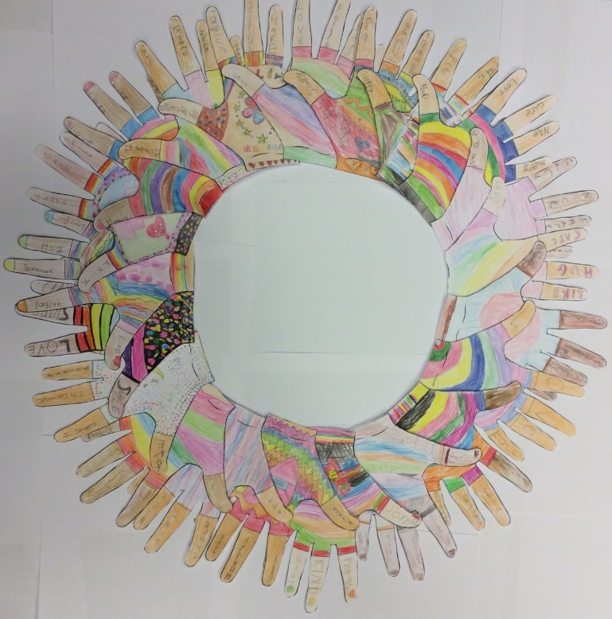

Artwork by Year 3

**Relational Bullying**

Relational bullying is causing harm to a person by damaging friendships. It describes behaviours that are much more hidden than other forms of bullying and are often among friendship groups. For example, the spreading of rumours, being excluded from groups and social events or using friendship as a tool of harm.

(Year 5)

**Verbal Bullying**

Verbal bullying is when you bully someone using words. For example, calling children names or mocking them. This hurts someone emotionally and can be difficult to spot.

(Year 5)

**Cyber Bullying**

Cyber bullying is when a child gets bullied through the internet, a game, or social media. As children are on their devices for a long period of the day, this issue is quite common. Most of the time, people get sent harmful texts. This is extremely similar to verbal bullying, however, it is mostly done by people who are too scared to say it face to face. Other examples include: blackmailing (where you threaten people to do something when the victim doesn't want to); posting hurtful images and videos (where you post a video/image of the victim without their permission); and sending hurtful e-mails and texts.

(Year 6)

**Physical bullying**

Physical bullying is one of the most noticeable forms of bullying. This is when someone harms a person by kicking, punching, or any other physical harm that is done over and over again. Most bullies do this to gain power and make other children scared of them. It can be easily identified because you can see it happening, but if you were not able to, bruises/scratches are good examples of proof. Most schools try to prevent physical bullying the most, as it is used more than any other type. Just like any other bullying form, it must be stopped as soon as possible.

(Year 6)

**Prejudicial Bulling**

Prejudicial bullying is when you make fun of someone or purposefully leave someone out because of their skin colour, race, religion, gender or disability. This is also linked to discrimination.

(Year 5)

**Sexual Bullying**

Sexual harassment/ bullying is an unacceptable problem, which needs to be stopped as soon as possible. This type of harassment is where a child or young adult is touched inappropriately or is treated differently/made fun of because of their sexuality. This is done usually by someone who wants to make the victim feel uncomfortable. If this ever happens to you, report the harasser instantly!

(Year 6)

**At Hollymount we say “No to all types of bullying”**

We expect our children to consistently behave in a positive manner. Children must follow the school rules, which reflect our core values. We do not tolerate bullying of any kind and work hard to educate our children on this subject. We work with them to provide an understanding of what bullying is, how to identify it and how to deal with it.

**EYFS and KS1** Embedded the importance of how to get along and be kind to one another. They looked at how their behavior and actions can affect others and what we can do to support each other.

**Hollymount’s Kind Words** 